## Information:

Opt League is especially designed for old laptops/Computers that run Windows 10. This Software is made to reduce all backend processes, such as your Desktop, OneDrive, and other processes that windows doesn’t need.

Some the Processes This Program Stops:

explorer.exe

OneDrive.exe

Chrome.exe

MicrosoftEdge.exe

SkypeApp.exe

WINWORD.exe

POWERPNT.exe

EXCEL.exe

YourPhone.exe

These Applications/Services cause Frame Rate drops during game play, and aren’t required my either the game, or windows to run.

WARNING: Any Windows 10 apps from the Microsoft store will not work.

## Use of this Application:

### Step 1:

A screenshot of a cell phone

Description generated with high confidence

The Finish Button has no Purpose right now.

This Launch Button Takes the User to the Next Step

### Step 2: Launch

A screenshot of a social media post

Description generated with very high confidence

This is a Message Alerting the User about what is going to happen.

### Step 3: OK

A screenshot of a cell phone

Description generated with high confidence

The Cancel Button Will Kill this Window.

The User is now required to enter their Current Computer Username All in Caps, to Make sure that The User is aware about the other Application shutdown. In our Example the User Name is Hasan.

### Step 4: OK



The Program has now closed all Unnecessary applications and Automatically Launched League of Legends, Minimizing the Window Will reveal a black background, and one window, when that window is moved the user then will have two windows.

### Step 5: Background

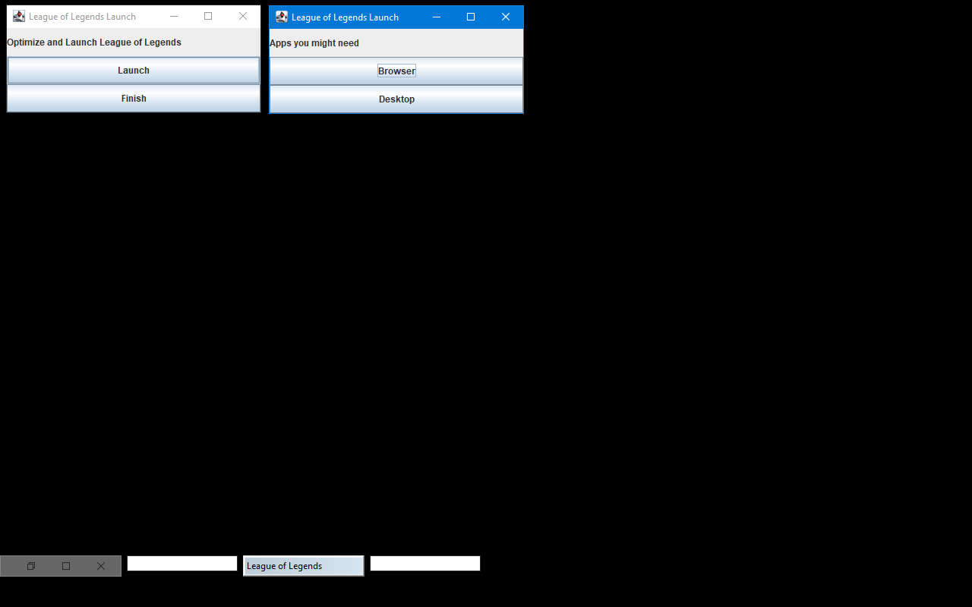

This Window also has two Windows, The Browser Button Opens the users Default Brower (Except Microsoft Edge). The Desktop Button opens the Desktop Backup.

This Window has two buttons, unlike before the Launch Button has no purpose, but the Finish button now will automatically close league, and open the User’s desktop back up.

### Step 6: Finished

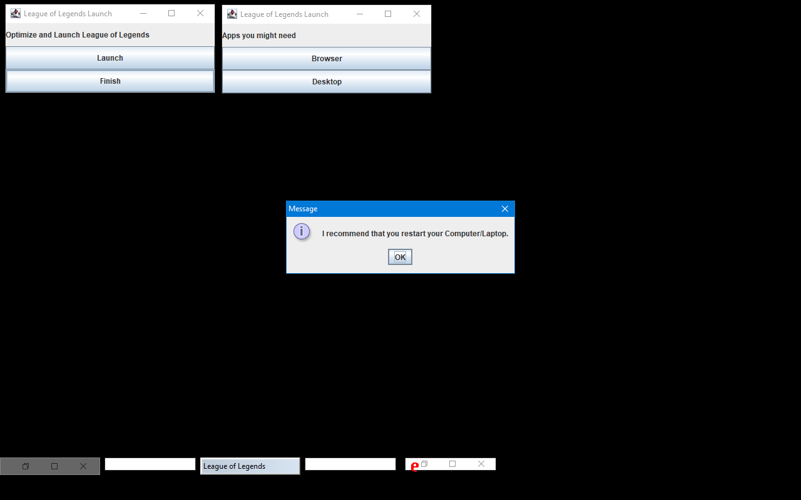

I recommend that the User Restart, their Computer/Laptop, but it’s the Users Choice.

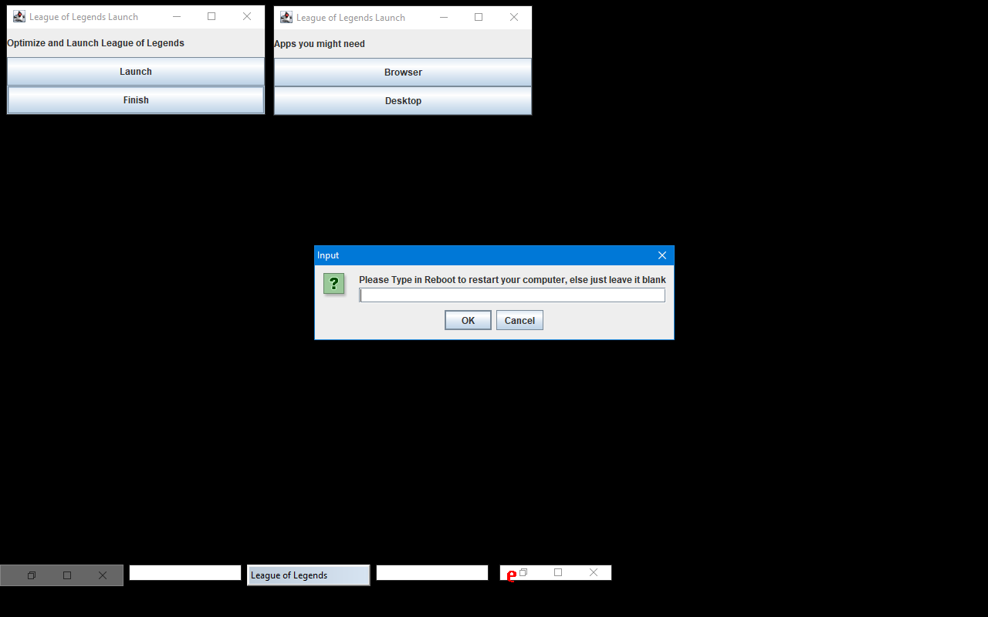

Making sure that the User is aware that their Computer/Laptop is about to reboot, if the User Types Reboot the Program will automatically reboot, and if nothing is typed in the Device will not restart. And the Program will automatically launch the User’s Desktop back up.